**STATISTICAL MACHINE LEARNING APPROACHES TO**

**LIVER DISEASE PREDICTION**

**Team ID : PNT2022TMID14267**

**Team Members :**

* Hemamalini B
* C Sri Vaishnavi
* D Sowmya Sen
* Harshavarthini S

# 1. INTRODUCTION

With a growing trend of sedentary and lack of physical activities, diseases related to liver have become a common encounter nowadays. In rural areas the intensity is still manageable, but in urban areas, and especially metropolitan areas the liver disease is a very common sighting nowadays. Liver diseases cause millions of deaths every year. Viral hepatitis alone causes 1.34 million deaths every year. Problems with liver patients are not easily discovered in an early stage as it will be functioning normally even when it is partially damaged. An early diagnosis of liver problems will increase patient’s survival rate. Liver failures are at high rate of risk among Indians. It is expected that by 2025 India may become the World Capital for Liver Diseases. The widespread occurrence of liver infection in India is contributed due to deskbound lifestyle, increased alcohol consumption and smoking. There are about 100 types of liver infections. With such alarming figures, it is necessary to have a concern towards tackling these diseases. Afterall, we cannot expect a developed and prosperous nation, with unhealthy youths. In this project we have taken UCI ILPD Dataset which contains 10 variables that are age, gender, total Bilirubin, direct Bilirubin, total proteins, albumin, A/G ratio, SGPT, SGOT and Alkphos and contains 415 as liver disease patients and 167 as non liver disease patients.As we got through the next parts of this paper we will explain what proccess as taken place for the selection of best model and building necccessary sytem for the prediction of liver disease. The major outcomes that can be expected through this project are:

* Increased convenience for predicting a liver disease➢ Reduction in number of deaths due to liver diseases
* More accurate diagnosis of liver disease by the doctors
  1. **Project Overview**

Liver Disease is a prominent Disease other than heart attack, which is taking a lot of lives. Since most of the time liver disease is detected at the later stage leading to death. Number of liver patients is increasing because of several reasons like over consumption of alcohol, breathing in injurious gas, consuming polluted water and so on which can affect health parameter. Using a machine learning prediction models, liver diseases can be predicted using those parameters in early stages. In this work to build the machine-learning models, Indian Liver Patient Dataset (ILPD) hosted at UCI.edu is used, which is based on Indian patient and Naive Bayes algorithm is used to predict the disease with different prepossing techniques. Dataset is checked for skewness, outliers and imbalance using univariate and bivariate analysis and then suitable algorithms used to remove outliers and various oversampling and undersampling techniques are used to balance the datal. Further refinement of model is done through hyperparameter tunning using grid search and feature selection. The Final model provides 100% accuracy and also good score across different metrics.

* 1. **Purpose**

The purpose of this project is used to predict the liver disease using Naive Bayes

Algorithm and this is used to predict the liver disease earlier and reduce the death rate .

# 2. Literature Survey

1. A COMPARATIVE STUDY ON LIVER DISEASE PREDICTION USING SUPERVISED MACHINE

LEARNING ALGORITHMS A.K.M Sazzadur Rahman, F. M. Javed Mehedi Shamrat, Zarrin Tasnim, Joy Roy, Syed Akhter Hossain Chronic Liver Disease is the leading cause of global death that impacts the massive quantity of humans around the world. This disease diagnosis is very costly and complicated. Therefore, this paper evaluates the performance of different Machine Learning algorithms in order to reduce the high cost of chronic liver disease diagnosis by prediction. Six machine learning techniques have been applied including Logistic Regression, K Nearest Neighbours, Decision Tree, Support Vector Machine, Naïve Bayes, and Random Forest. The performance was evaluated on different measurement techniques such as accuracy, precision, recall, f-1 score, and specificity and the result was that LR achieved the highest accuracy. --ResearchGate – 2019

1. MACHINE LEARNING-BASED LIVER DISEASE DIAGNOSIS:

A SYSTEMATIC REVIEW Rayyan Azam Khan, Yigang Luo, Fang Xiang Wu

This paper mainly focuses on the computer-aided diagnosis of hepatic lesions in view of diffuse- and focal liver disorders. This is based on three image acquisition modalities: ultrasonography, computed tomography, and magnetic resonance imaging. Insightful analysis is presented for each preliminary step, particularly preprocessing, attribute analysis, and classification techniques to accomplish clinical diagnostic tasks. In preprocessing denoising, deblurring, and segmentation methods are used. Denoising is mainly performed with nonlinear models. --ScienceDirect – 2022

3. DIAGNOSING OF LIVER DISEASE PREDICTION IN PATIENTS USING COMBINED MACHINE

LEARNING MODELS

Chokka Anuradha, D Swapna, Balamuralikrishnan Thati IEEE

In the human body one of the most important organs is the liver. If the regular functionality of the liver is disturbed then this condition is called disease-affected liver. Therefore, an early stage of disease detection is more important which helps in disease prevention at starting stage with small medications. But it is too difficult to identify Liver disease at the early stages because symptoms are very less at the starting stage. Lab results with physical examination are involved in the Traditional methods. This paper aims to represent a Diagnosing for Liver disease prediction in Patients using Combined Machine Learning Models. Optimized three machine learning algorithms are used for the accurate diagnosis of liver disease and they are Artificial Neural Networks (ANN), Decision Trees, and K-Nearest Neighbours (KNN). With the help of these algorithms, given data is classified and results are produced. The future data is predicted with the help of past and present data. The accuracy results are produced by comparing three classification algorithms

. 4. STATISTICAL MACHINE LEARNING APPROACHES TO LIVER DISEASE PREDICTION

Fahad Mostafa, Easin Hasan, Morgan Williamson, Hafiz Khan M

L algorithms are trained to detect the possibility of liver disease to assist healthcare workers. Correlation of chosen variable with the risk of liver disease is performed to train the model. ML methods were able to identify the liver disease with high accuracy. The PCA results showed five important factors for liver disease diagnosis: AST, ALT, GGT, BIL, and ALP. In a real situation, a clinician can strongly suspect liver disease using only these five variables, as they are very descriptive for liver function. The ratio of ALT and AS denotes the cause of a liver injury. GGT and ALP increase in circulation with the severity of a liver injury. Additionally, the injury proximity to the bile duct is determined by the concentration of ALP. This study shows several machine learning approaches with PCA, which outperformed the classification. Among three ML classification methods, the performance of SVM and RF is better than ANN. --MDPI - 2021

1. LIVER DISEASE PREDICTION SYSTEM USING MACHINE LEARNING TECHNIQUES

Rakshith D B, Mrigank Srivastava, Ashwani Kumar, Gururaj S P

In this paper risk of liver disease for a person is predicted based on the blood test report results of the user. With the dataset used for this project, 100 % accuracy is obtained for SVM model. The data pre processing was done using Jupyter Notebook and Desktop Application was Implemented using Sypder IDE.The programming language which was used is python and machine learning Sklearn was used to build the model using classification algorithm like KNN,SVM,Naive Bayes and ANN. --IJERT – 2021

1. STATISTICAL MACHINE LEARNING APPROACHES TO LIVER DISEASE PREDICTION

International Journal of Scientific Research and Engineering Development – 2022

This study attempts to find an appropriate machine learning algorithm that can determine whether a person has liver disease or not given a dataset containing biological and diagnostic data of 583 Indian patients. Using certain characteristics such as total bilirubin, direct bilirubin, alkaline phosphatase, total protein, albumin, and globulin, this software can determine whether a patient has liver disease or not. --Robin Biju

* 1. **Existing Problem**

The main Problem is doctors cannot diagnose on the basis of variation in the test result .In this Application ,by using patient records that includes blood test report results,we will determine which patient has liver disease and which ones do not in an accurate and faster way.

* 1. **References**

1.A.K.M Sazzadur Rahman, F. M. Javed Mehedi Shamrat, Zarrin Tasnim, Joy Roy, Syed Akhter Hossai

2. MACHINE LEARNING-BASED LIVER DISEASE DIAGNOSIS A SYSTEMATIC REVIEW Rayyan Azam

Khan, Yigang Luo, Fang Xiang Wu

3.. DIAGNOSING OF LIVER DISEASE PREDICTION IN PATIENTS USING COMBINED MACHINE

LEARNING MODELS Chokka Anuradha, D Swapna, Balamuralikrishnan Thati

4.STATISTICAL MACHINE LEARNING APPROACHES TO LIVER DISEASE PREDICTION Fahad Mostafa,

Easin Hasan, Morgan Williamson, Hafiz Khan –-MDPI - 2021

5. LIVER DISEASE PREDICTION SYSTEM USING MACHINE LEARNING TECHNIQUES Rakshith D B,

Mrigank Srivastava, Ashwani Kumar, Gururaj S P –--IJERT – 2021

6.. STATISTICAL MACHINE LEARNING APPROACHES TO LIVER DISEASE PREDICTION International

Journal of Scientific Research and Engineering Development – 2022—--Robin Biju

**2.3 Problem Statement Definition**

The main problem is doctor cannot diagnosis on the basis of variations in test results.

# 3. IDEATION AND PROPOSED SOLUTION

**3.1. Empathy Map Canvas**

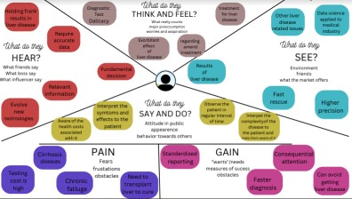

**3.2. Ideation and Brainstorming**

**Step 1:** Team Gathering, Collaboration and Select the Problem Statement

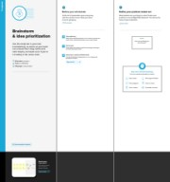

**Step 2:** Brainstorm, Idea Listing and Grouping

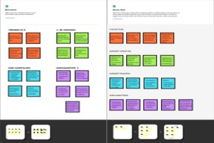

**Step 3:** Idea Prioritization

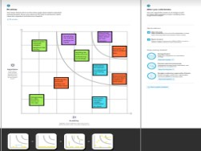

**3.3. Proposed Solution**

|  |  |
| --- | --- |
| **s.no** | **Parameter Description** |

**1.** Problem Statement (Problem to be solved)

|  |  |
| --- | --- |
|  | is very difficult to identify the liver disease in early |

Nowadays many peoples are affected by Liver disease because of that so many people are losing their life. Early detection of liver disease can be very helpful in the treatment of the disease to fast

recover but it

|  |  |
| --- | --- |
|  | stages. In some situations, the  medical expert is unable to detect the symptom even at an early stage. It is one of the great losses for the patient |
| **2.** | Idea / Solution description The software will detect the  patients symptoms and it will fin  d  out the disease according to that symptom and it will show the result by ML techniques. We will do  this by taking the data set of both  normal and abnormal liver and w  e  will train the software in that way by detecting the disease accordin g to the symptom. |
| **3.** | Novelty / Uniqueness In this software model we're not  t also giving some basic precautions like what to do  &  don't.which makes this mo del unique |

|  |  |
| --- | --- |
| **4.** | Social Impact / Customer  Satisfaction Many liver disease are left  unpredicted.By implementing thi  s software liver disease can be diagnosed in early stages which  result in the decrease of death r ate |
| **5.** | Business Model (Revenue Model) Currently the global is running with |
|  | newest technology likewise our  project will more helpful to medi cal fields. And the medical institutio n ,  clinics and hospitals need to pai d  for yearly license and get renew  yearly to continue the check up using this software |
| **6.** | Scalability of the Solution The software will never show the  new types of liver diseases in  future because the algorithm  and datasets we provided only f  or  the current liver diseases in case of any new liver diseases founde d  in future it will show as a error in  output we need to change the algorithm process to show witho ut error in future. |

**3.4.ProblemSolutionFit**

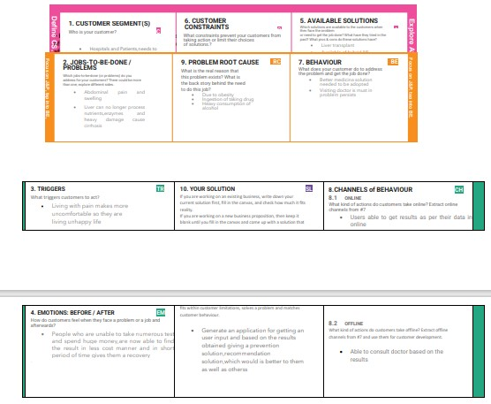

# 4. REQUIREMENT ANALYSIS

**4.1. Functional Requirements**

|  |  |  |
| --- | --- | --- |
| FR No | Functional Requirements(Epic) | Sub Requiremen t  ( Story/Sub Tas k) |
| FR 1 | User Registration | Registration through Gmail |
| FR 2 | User Confirmation | Confirmation via Email |
| FR 3 | Prediction | Liver Disease can be Predicted more Accurat ely by using Support Vector  Machine Algorithm |
| FR 4 | Hardware Requirements | 2GB RAM(minimum)  100GB HDD(minimum)  Intel i3 quad core 1.66G Hz processor(minimum) Internet Connectivity |
| FR 5 | Software Requirements | Windows 7 or higher  Python 3.6.0 or higher  Visual Studio Code Flask  (python platform) HTML  Dataset consisting of Liv er Disease Required librarie s  Jupiter notebook |
| FR 6 | Other requirements | IBM cloud login Chro  me  extension features |
| FR 7 | Events | Model needs a capability of retrieving and displaying |
|  |  | accurate result |

**4.2. Non-Functional Requirements**

|  |  |  |
| --- | --- | --- |
| **NFR No** | **Non Functional Requirements** | **Description** |
| **NFR 1** | Usability | This system is really use d as it can able to detect Liver Disease .By detecti ng the liver disease early ,death rate is decreased |

|  |  |  |
| --- | --- | --- |
| NFR 2 | Security | Assuring all data inside t he system or its part will be  Protected |
| NFR 3 | Reliability | This Approach gives mo re accuracy than the existi ng solution |
| NFR 4 | Performance | The effectiveness of the se methods relies on featur e collection, training data, and classification algorithms. It must be processed and execut ed within a fraction of a second using the Machi ne learning algorithm |
| NFR 5 | Availability | It doesn’t have any |
|  |  | restrictions , it is availab le for all individual user |
| NFR 6 | Scalability | It is acceptable to fit the m over any place and any resources. |

# 5. PROJECT DESIGN

**5.1 Dataflow Diagrams**

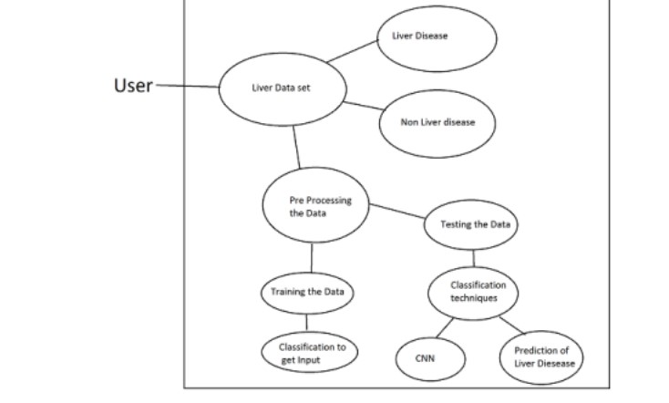

**5.2. Solution Architecture**

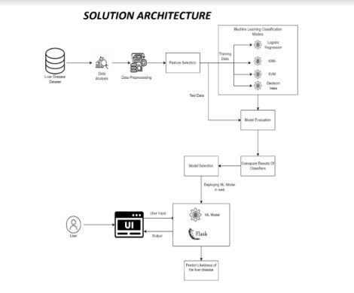

**5.3. Technical Architecture**

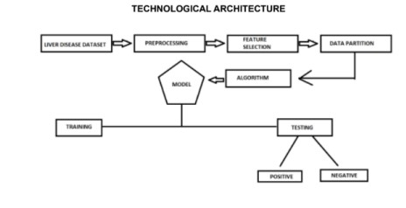

**Table-1: Components & Technologies**

|  |  |  |
| --- | --- | --- |
| S.No | Component Description | Technology |
| 1 | User Interface How user interact s with application e .g.  Web UI, Mobile Ap p, Chatbot etc. | HTML, CSS,  JavaScript |
| 2 | Application Logic-1 Logic for a proce ss in the application | Python |
| 3 | Application Logic-2 Logic for a proce ss in the application | IBM Watson S  TT service |
| 4 | File Storage Files are stored in cloud | IBM Block Stora  ge  or Other Storage Service or Local |
|  |  | Filesystem |
| 5 | Machine Learning Model Prediction of Liv er Disease | Support Vector  Machine Algorith m |
| **6** | Infrastructure (Server / Cloud) IBM Cloud App Configuration  is  a  centralized featu  re  management an d configuration service on IBM  Cloud | IBM Cloud Fou  nd ry,  Kubernetes, etc. |

**Table-2: Applications Characteristics**

|  |  |  |
| --- | --- | --- |
| **S.No** | **Characteristics Description** | **Technology** |
| **1** | Open-Source Frameworks There are no ope n  source frameworks in this application  . | Technology of Opensource framework |
| **2** | Security Implementations Block chain  technology is us  ed for Security implementation i ts  private framewo rk  protects all data.  . | Block chain |
| **3** | Scalable Architecture Users are Provided  with medical services online | IBM cloud |
| **4** | Availability Available for | Technology used |
|  | everyone , no  Restrictions |  |
| **5** | Performance Predicted Result is  more accurate | Support Vector  Machine Algori th m |

**5.3 User Stories**

|  |  |  |  |  |  |  |
| --- | --- | --- | --- | --- | --- | --- |
| **User Typ e** | **Functio nal Require**  **m**  **ent (Epi**  **c)** | **User**  **Story**  **Number** | **User**  **Story/Task** | **Acceptan ce criteria** | **Priority** | **Release** |

|  |  |  |  |  |  |  |
| --- | --- | --- | --- | --- | --- | --- |
| **Custom er**  **(Mobile user)** | **Registr ati on** | **USN-1** | As a user, I c  an  register for t  he  application b  y  entering my email, password, a nd  confirming  my password.. | I can  access  my  account  /  dashboar d | High | Sprint 1 |
|  | **verify /**  **Login** | **USN-2** | As a user, I will receive  confirmation email once I have register ed for the  application | I can  receive  confirm  ati  on email  & click confirm | High | Sprint 1 |

|  |  |  |  |  |  |  |
| --- | --- | --- | --- | --- | --- | --- |
|  | **Monitori**  **ng** | **USN-3** | As a user, I c  an  monitor the | I can do it  from any | High | Sprint 2 |
|  |  |  | account place  process to access . | |  |  |
| **Custom er (Web user)** | **Dashboa**  **rd**  **Getting**  **informati on** | **USN-4**  **USN-5** | All the login  Helpful f or  process and  remindin  activities do  g  ne will be  the actio  displayed on  ns  the dashboard  As a user, I  I can  need to gath  collect all  er the  the informati  Informatio n  on  from the real scenario | | Mediu  m  High | Sprint 2  Sprint 1 |
| **Custom er Care**  **Executive** | **Analysing USN-6** | | As a User, I  Helpful to  need to analy  Predict t  se  he  the informati  disease  on  early  and get into t he decision to predict the disease | | High | Sprint 2 |
| **Admini**  **str ator** | **Ordering USN-7** | | As a user, I  Iam the  would order  higher  my  Authority  officers to hel and I can  p the user to  order the  m  predict the disease | | High | Sprint 2 |
|  |  | | As a user, I will I will try to | | High | Sprint 1 |

**USN-8** observe the l account. If a surely take

ny actions to avo

prediction of id them disease go manage t he

es situation

wrong, I wil

|  |  |  |  |  |  |
| --- | --- | --- | --- | --- | --- |
|  | **Obeying**  **Orders** | **USN- 9** | As a user I ne  I am in th  ed to obey my e way to ob  higher office  ey  rs  the orders  command a nd  take measur es mentioned b y them | Medium | Sprint 2 |

# 6. PROJECT PLANNING &SCHEDULING

**6.1. Sprint Planning & Estimation**

|  |  |  |  |  |  |
| --- | --- | --- | --- | --- | --- |
| **Sprint** | **Functio**  **nal**  **Require**  **m**  **ent (Epi**  **c)** | **User**  **Story**  **Number** | **User Story / Task Story Points** | **Priority** | **Team Members** |

Sprint-1 User Input USN-1 Test datas are given as input f

or prediction

10 High M.Ashmit ha,

Priya

L.R.Devi

|  |  |  |  |  |  |
| --- | --- | --- | --- | --- | --- |
| Sprint-1 | USN-2 Model compar  es  the given data with the Liver  disease affect  ed data | | 10 | High | J.Thersal,  R.Sruthi |
| Sprint-2 | Prediction USN-3 Model predicts  the liver disea se  using Machin  e  Learningalgorith m  Support Vector  Machine(SVM) | | 10 | High | J.Thersal,  M.Ashmith a |
| Sprint-3 | Classifier USN-4 Model sends a  ll  the output to t he  classifier and produces the fi nal result. | | 10 | High | R.Sruthi,  L.R.Devi  Priya |
| Sprint-4 | Announ  ce ment | USN-5 Model then  displays wheth  er  the patient is affected by liv er  disease or no t | 10 | High | J.Thersal,  R.Sruthi |
|  | Events This model nee  ds  the capability of displaying accurate result | | 10 | High | M.Ashmit ha,  L.R.Devi  Priya, |

**6.2. Sprint Delivery Schedule**

|  |  |  |  |  |  |
| --- | --- | --- | --- | --- | --- |
| **Sprint** | **Total**  **Story**  **Poi nts** | **Duratio n** | **Sprint St**  **Sprint end**  **art Date**  **Date**  **(Planned)** | **Story points**  **Comple te**  **d(as on**  **Planned**  **End**  **Points)** | **Sprint**  **Release**  **Date**  **(Actual)** |
| Sprint-1 | 20 | 6 Days | 24 Oct 2022 29 Oct 2022 | 20 | 20 Oct  2022 |
| Sprint-2 | 20 | 6 Days | 31 Oct 2022 05 Nov 2022 | 20 | 05  Nov2022 |
| Sprint-3 | 20 | 6 Days | 07 Nov 202  12 Nov 2022 2 | 20 | 12  Nov2022 |
| Sprint-4 | 20 | 6 Days | 14 Nov 202  19 Nov2022 2 | 20 | 19  Nov2022 |

**Velocity**

Imagine we have a 10-day spirit duration ,and the velocity of the team is

20(points per spirit). Let's calculate the team average velocity(AV) per iteration unit

(story points per day)

## AV= Spirit Duration/Velocity =20/10 =2 Burndown Chart

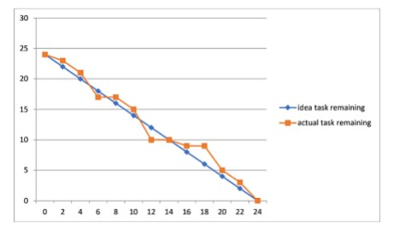

**6.3 Reports from JIRA**

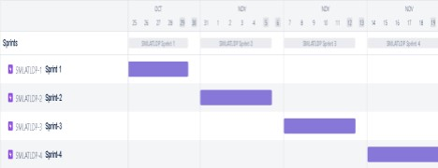

# 7.CODING AND SOLUTIONING

**7.1 Feature**

**Login Page:** The login page ask the user to enter the data of test result.

**Result Page:** The result page tells whether the person has liver disease or not.

## 7.2 Codes home: index

<!DOCTYPE html>

<html lang="en">

<head>

<meta charset="UTF-8">

<meta http-equiv="X-UA-Compatible" content="IE=edge">

<meta name="viewport" content="width=device-width, initial-scale=1.0">

<title>Document</title>

<style>

table

{

width:100%;

}

td

{

height:50px;

width:50px;

}

</style>

</head>

<body>

<form method="POST" action="/predict">

<table>

<tr>

<td>

<label for="age">Age :</label>

</td>

<td>

<input type="number" name="age" step=0.1/>

</td>

</tr>

<tr>

<td>

<label for="gender">Gender :</label>

</td>

<td>

<input type="number" name="gender" step=0.1/>

</td>

</tr>

<tr>

<td>

<label for="total_bilirubin">Total Bilirubin :</label>

</td>

<td>

<input type="number" name="total_bilirubin" step=0.1/>

</td>

</tr>

<tr>

<td>

<label for="alkaline_phosphotase">Alkaline Phosphotase :</label>

</td>

<td>

<input type="number" name="alkaline_phosphotase" step=0.1/>

</td>

</tr>

<tr>

<td>

<label for="alamine_aminotransferase">Alamine Aminotransferase :</label>

</td>

<td>

<input type="number" name="alamine_aminotransferase" step=0.1/>

</td>

</tr>

<tr>

<td>

<label for="aspartate_aminotransferase">Aspartate Aminotransferase :</label>

</td>

<td>

<input type="number" name="aspartate_aminotransferase" step=0.1/>

</td>

</tr>

<tr>

<td>

<label for="total_protiens">Total Protiens :</label>

</td>

<td>

<input type="number" name="total_protiens" step=0.1/>

</td>

</tr>

<tr>

<td>

<label for="albumin">Albumin :</label>

</td>

<td>

<input type="number" name="albumin" step=0.1/>

</td>

</tr>

<tr>

<td>

<label for="albumin_and_globulin_ratio">Albumin and Globulin Ratio :</label>

</td>

<td>

<input type="number" name="albumin_and_globulin_ratio" step=0.1/>

</td>

</tr> <tr>

<td>

</td>

<td>

<button type="submit">Diagonise</button>

</td>

</tr>

</table>

</form>

</body

</html>

## Predict

<!DOCTYPE html>

<html lang="en">

<head>

<meta charset="UTF-8">

<meta http-equiv="X-UA-Compatible" content="IE=edge">

<meta name="viewport" content="width=<device-width>, initial-scale=1.0">

<title>Document</title>

</head>

<body>

<h1>The predicted result is</h1>

<h1>{{predict}}</h1>

<a href="/">Go Back</a>

</body>

</html>

**8.TESTING**

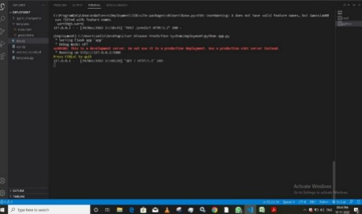

**9. RESULTS**

In this Project,we found that Liver disease can be Predicted using the test resul t values.

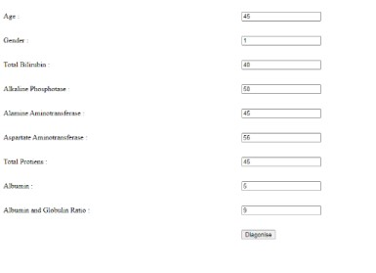

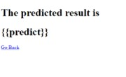

# 10. ADVANTAGES AND DISADVANTAGES

**Advantages:**

1. No medical expertise required: You dont need to have any knowledgeof medical science and Liver Diseases to predict the Liver disease using this application. All you need to do is enter the details being asked, which are already present in the blood test report and then you will get the result of prediction.
2. High Accuracy: This system predicts the results with 100% accuracy for thedataset that we have use while creating this application. While the accuracy might be different in some cases, It will still be high enough to be trustworthy at a large scale.
3. Immediate results: The result here are predicted within seconds ofentering the details. You dont need to wait for a doctor to come, unlike in traditiona l method.

**Disadvantages:**

* 1. Due to any network issue there will be a delay in getting the predicted result
  2. It is difficult to implement these techniques in some rural area
  3. There is a possibility of entering wrong data so that the predicted result goes wrong

# 11. CONCLUSION

The mechanisms that are currently used in the prediction of liver disease are prone to have different levels of accuracy and effectiveness. Different diseases demand accuracy of a different set of parameters and might not demand the same set of inferences, throughout more than a single case. In the near future, the study reflects that there was a decent amount of accuracy that was achieved. However, the agenda of our paper is to improvise on those lines and come up with better accuracy standards. The following are some of the clear limitations that have been observed, in order to account for innovation in this paper, having brought about the connotation of improvising on these lines. When it comes to the classification process, it is not necessary that the cohesion that a classifier shares with a particular set of data should stand viable for the rest of the training set. This is to imply that there are some classifiers that don't stand fit to the data set in the context. There are certain methodologies that are incompatible and non-cohesive when it comes to the collection of real-time data and the implementation procedures of the same. Some of the machine learning approaches that are being considered, do not stand viable for a large volume of data.

# 12. FUTURE SCOPE

In the future ,we can apply different deep learning and transfer learning algorithms with various feature selection techniques for classifying liver patients and we can use in another set of data and check for the prediction accuracy. And also, we can work on more parameters which help to get better performance .

# 13. APPENDIX

**Source Code:**

**import flask from flask import request,render_template from flask_cors import CORS**

**import joblib import sklearn**

**app=flask.Flask(__name__,static_url_path='') CORS(app)**

**@app.route('/',methods=['GET']) def SendHomePage():**

**return render_template('index.html')**

**@app.route('/predict',methods=['POST']) def predictResult():**

|  |  |
| --- | --- |
| **a=float(request.form['age'])** |  |
| **b=float(request.form['gender'])** | |

**c=float(request.form['total_bilirubin'])**

**d=float(request.form['alkaline_phosphotase'])**

**e=float(request.form['alamine_aminotransferase'**

**])**

**f=float(request.form['aspartate_aminotransferas e']) g=float(request.form['total_protiens']) h=float(request.form['albumin'])**

|  |  |
| --- | --- |
| **i=float(request.form['albumin_and_globulin_ratio'])** | |
| **x=[[a,b,c,d,e,f,g,h,i]]** |  |

**model=joblib.load('selected_model.pkl') result=model.predict(x)[0] if(result==2):**

**res="Liver Disease Predicted" else:**

**res="No Liver Disease Predicted"**

**return render_template('predict.html',predict=res)**

**if __name__=='__main__': app.run()**

**Github:** [**https://github.com/IBM-EPBL/IBM-Project-40021-1660614662**](https://github.com/IBM-EPBL/IBM-Project-40021-1660614662)

**Project demo link:**

<https://drive.google.com/file/d/1Bc9FV8kPEC_C_-mC2hwTeFbQqps90hZo/view?usp=drivesdk>